Bug Report
Reporter: Huang Wenjie
Email: wenjiezander@gmail.com
Library Name: Recutils
Version: 1.8
Component: csv2rec
Operating System: Ubuntu 20.04.2 LTS
Download link for crash seed: https://drive.google.com/file/d/1zEzaZt-JKqAncYNcnQ6ivJGaNvzmCxEa/view?usp=sharing
Bug found (Fig. 1):
Deference of a high value address.
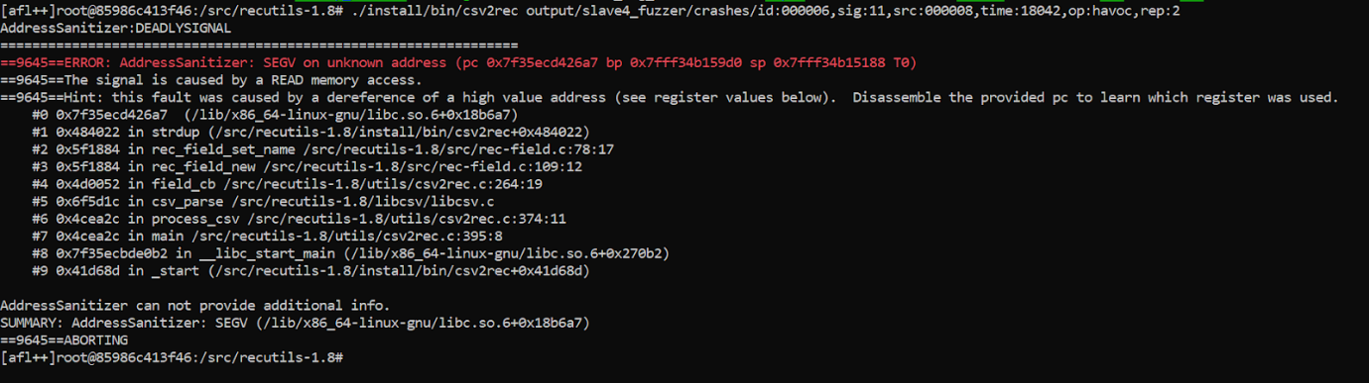
Fig. 1

Steps to reproduce the bug:
- In recutils-1.8, compile csv2rec into a binary executable
  - ./configure
  - make
  - make install
- Run the executable with the crash_seed (A download link for the crash seed is provided above)
  - ./csv2rec crash_seed

Observation:
The variable “name” with an invalid address is passed in to the function “rec_field_set_name” in “recutils-1.8/src/rec-field.c:109” and the function “strdup” in “rec_field_set_name” tries to read from the invalid address which results in a deference of a high value address. A proof of the invalid address is shown in Fig. 2.

Further investigation is required to examine the reason that this invalid address is produced.
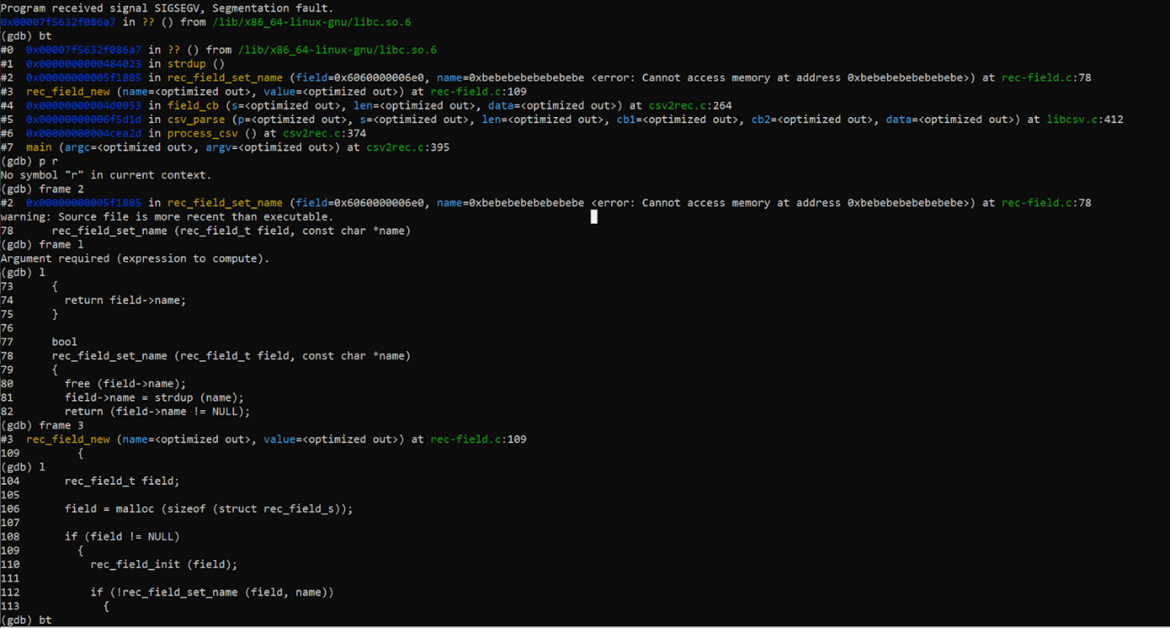
Fig. 2

